Lab 221 Assignment | Type: | Short Assignment
 | Code: | J2.S.P0104
 | LOC: | 60
 | Slot(s): | 1

Title
Browse by line in JTable
Background Context
NA

Program Specifications
Create a program to browse by line on a data collection as table.

Function details:
NA

Expectation of User interface:
The screen when the program startup should be as:

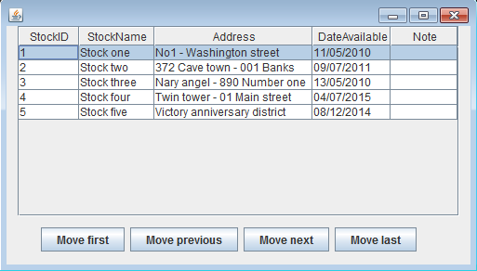

- Click “Move last” button:

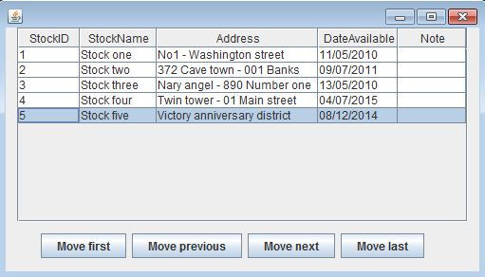

- Click “Move previous” button:

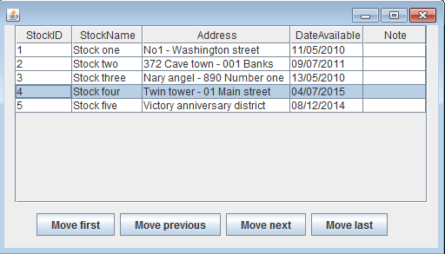

- Click “Move first” button:

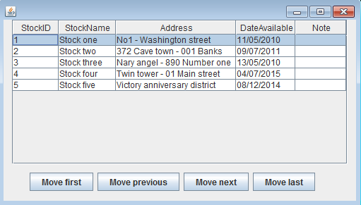

- Click “Move next” button:

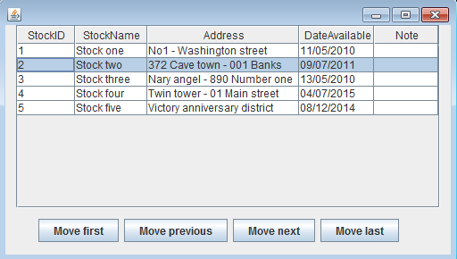

Guidelines
- Using your own data

